Kate Morris 498 words

**Morrison, George (American; Chippewa 1919-2000)**

George Morrison was a Native American painter who played an active role in the formation of Abstract Expressionism. Morrison attended the Art Students League in New York City from 1943-1946, and was considered a member of the New York School, exhibiting alongside Franz Kline, Willem de Kooning, Ad Reinhardt, Louise Bourgeois, Mark Rothko, and others. Morrison’s paintings rarely contained overtly Indian signifiers, yet his early interest in nature and the unconscious, and his engagement with Surrealist practices such as automatism, made him an ally of modern primitivism. His experimentation with non-figural and biomorphic forms led him to develop a mature style of abstraction that combined colour-field and gestural approaches: he is best known for large-scale paintings, drawings, and wood collages that convey rhythmic and tactile sensations of the urban and natural environment. From 1970 to 1983 Morrison was a member of the faculty of the studio arts department at the University of Minnesota, and from 1983 until his death in 2000 he lived and worked on the Grand Portage Indian Reservation on the shore of Lake Superior. In 2004, Morrison was one of two artists featured in the inaugural exhibition of the Smithsonian National Museum of the American Indian.

Morrison was born and raised near the Grand Portage Indian Reservation in Chippewa City, Minnesota. After attending a Bureau of Indian Affairs boarding school and public high school, he earned a Bachelor of Fine Arts in painting at the Minneapolis School of Art. From the mid-1940s through the early 1960s, Morrison split his time primarily between New York City and Provincetown, Massachusetts, with a year-long interlude spent in Paris and Aix-en-Provence on a Fulbright Fellowship in 1952. In 1965, while a member of the faculty of the Rhode Island School of Design, Morrison began to construct collages from driftwood found on the beaches of Cape Cod. These constructions, which the artist referred to as “paintings in wood,” were likely inspired by Morrison’s friend Louise Nevelson, with whom he exhibited at Grand Central Moderns Gallery in New York. Whereas Nevelson’s wood structures were often oriented vertically and incorporated spaces between elements, Morrison’s are densely packed mosaics arranged in resolutely horizontal compositions. Morrison’s appreciation of the natural color, texture, and grain of his materials inspired him to leave the works unpainted, underscoring their reference to the landscape and forces of nature. Following his retirement and move back to the reservation in 1983, Morison began work on a series of acrylic paintings known as the *Red Rock Variations* or simply, the *Horizon* paintings. Each abstract landscape features a luminous horizon line placed high in the composition, which both animates and calms the turbulent washes of colour that flow across the surface of the canvas.

**References and Further Reading:**

Lowe, T. (ed.) (2004) *Native Modernism: The Art of George Morrison and Allan Houser*, Washington, D.C.: Smithsonian National Museum of the American Indian.

Rushing, W. J. and K. Makholm (2013) *Modern Spirit: The Art of George Morrison*,Norman, OK: University of Oklahoma.

--------

Illustrations:

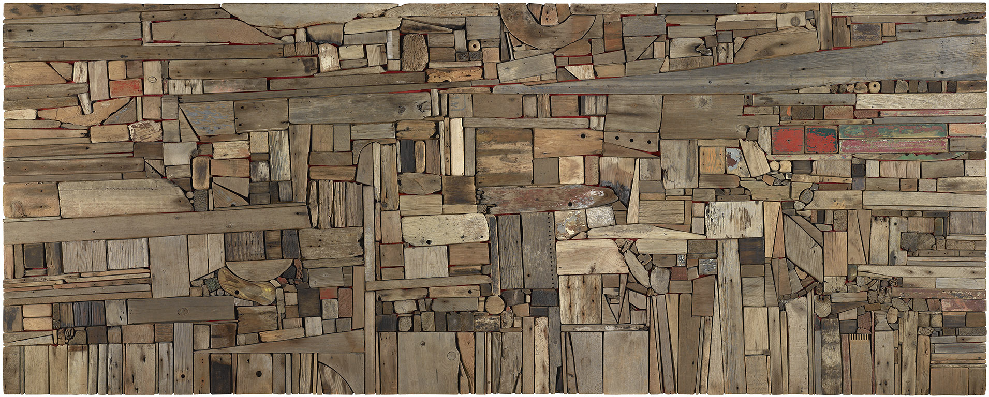

*New England Landscape II* (1967) wood, 48x120x3”

Amon Carter Museum of American Art, Fort Worth, Texas 1968.273

<http://www.cartermuseum.org/custom/acm_display.php?irn=59071&QueryPage=%2Fcustom%2Findex.php>

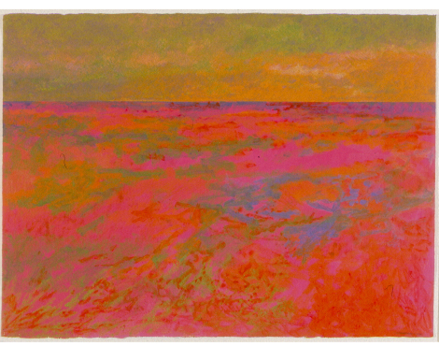

*Spirit Path, New Day, Red Rock Variation: Lake Superior Landscape* (1990) acrylic and pastel on paper 22.5x30”

Minnesota Museum of American Art 99.04.02.03

<http://mmaa.org/pages/ModernSpirit>